COVID-19 Protocols for NZ Forestry Industry Operations under Level 3 – Extract for Transport and Ports
This document uses the Ministry of Health and Ministry for Primary Industries guidelines, which describe general safety measures to control the spread of COVID-19:
- Stay at home if unwell
- Wash hands
- Sneeze / cough into tissue / elbow (tissues in bin)
- Maintain physical distancing.
- Masks must be worn if there is contact with anyone outside of your work bubble.
- Scanning the QR codes or sign a register to facilitate contact tracing is compulsory.
- Use PPE (clothing, masks, gloves) as an optional measure appropriate to the circumstances
- Form bubbles to minimise mixing of teams
- Visitors / other service providers to maintain safe practices and physical distancing
- Implement an appropriate cleaning and disinfecting programme

Recommended Practices for COVID-19: Everyone
- Stay at home if you are unwell
- Everyone must self-assess their health prior to attending work. Anyone who feels unwell should not come to work and should phone Healthline on 0800 358 5453 to seek advice.
- Anyone who has been in another country or has had close contact with a probable or confirmed case, should self-quarantine and not come to work for 14 days.
- Assess worker fitness before work starts each day by asking them: Are you feeling unwell, fatigued or not in a fit state to work?
- Have you been in contact with anyone who is unwell or who has COVID-19?
- For more information see Appendix 3: Assessing wellness.

- Minimise numbers on site
- Only workers necessary to carry out work should be on site. Any worker who can work from home should.
- Visitors to site should be minimised to essential work only.

- General hygiene
Practise good hygiene at ALL TIMES including:
- Cover your coughs and sneezes with your elbow or a tissue
- Put used tissues straight into the bin
- Wash your hands often with soap and water, including before and after eating and after going to the toilet
- Use hand-sanitiser
- Avoid touching your eyes, nose and mouth
- Clean and disinfect frequently used hard surfaces at regular intervals
- Clean and disinfect frequently used objects such as mobile phones, keys, wallets, and work passes.
- Use PPE options as appropriate to the circumstances, which should include providing instruction on correct use.
- Form workplace teams (bubbles) and minimise mixing e.g. staggered breaks, defined walkways, separate entry and exit times.

- Have hygiene and cleaning products available on site
All works sites should have the following available:
- Soap and water
- Hand-sanitiser
- Cleaning products for wiping down areas
- Disposable paper towels to wipe down surfaces
- Tissues
- Gloves
- Bins / bags / waste areas to dispose of used cleaning items.

- Physical distancing
Maintain physical distancing between people:
- Level 3: 1 metre at work, 2 metres outside home or on public transport
- Level 4: 2 metres, unless 1 to 2 metres unavoidable e.g. in processing

Separation can be assisted through staggering start / finish / and meal break times. As far as is possible, people should remain in their work ‘bubble’.
General safety provisions need to be in place at all times and it is important that all businesses adapt safety measures to their specific circumstances.
Workers are only allowed to work with physical distancing of less than 1 metre in extraordinary operational circumstances. Additional safety measures such as screens must be applied, and these are described in guidance from Ministry for Primary Industries

The following requirements for distancing should be discussed and agreed with teams:
- Stagger breaks so that there are no communal lunches, smoko or other gatherings
- Maintain the required minimum distancing
- Only necessary workers should attend meetings, e.g., toolbox
- Handheld two-ways are to be used to reduce close contact between crew and visitors.

- Site register
Ensure you display a Covid-19 QR code or have a register for all employees, visitors and service providers with contact details recorded to ensure contact tracing can be done by Ministry of Health if there is a COVID-19 case at your workplace.

- Case management
Every workplace must maintain and implement processes for managing a positive COVID-19 detection in the workplace.
If there is a suspected or confirmed case of COVID-19 at work or at home contact Healthline on 0800 358 5453.

- Travel to and from work site
  - Wherever possible employees are to travel individually to and from a work site. Where this is not possible please see Appendix 5 for further details.
  - At home maintain good hygiene and follow the latest Ministry of Health guidance on physical distancing, including what social and recreational activities are allowed.

- Shared vehicle (split shifts, different users on different days etc)
Where a vehicle or machine is shared between different drivers / operators, each user must wipe down at the beginning and end of each use:
- Interior (including high touch areas such as steering wheel, gear shift, seat belt and buckle, radio, window controls etc)
- Any handheld devices left in the vehicle (where possible individuals to retain their own handheld devices)
- Two-way radio
- Exterior high touch areas including door handles
- Keys and or remote sensor.

- Returning home
- Clean your hands: Avoid touching anything until you wash or sanitise your hands thoroughly
- Remove shoes. Don’t walk through the house with your shoes on. Take them off at the door
- Wash clothes: Put your clothes and bags into a separate container from your family’s clothes and wash them in a hot washing machine cycle (over 60 degrees)
- Shower: Have a shower and make sure to wash your hands, wrists, neck and anywhere else that has been exposed.

- Fuel purchases
- Use hand-sanitiser or wash hands with soap and water both before and after refuelling vehicles.

- ‘At-Risk’ employees
- Employees who are most at risk should discuss options with their employer. Where appropriate, an employer may recommend such employees are relocated or assigned alternate duties for added protection.

- All meetings to be conducted remotely or to use physical distancing
- All meetings should be conducted using either phone conference, video conference or other technologies which can be set up to be accessed by laptop, tablet or smartphone
- All communications for onsite meetings such as tailgate meetings should now take place in a way that maintains physical distancing or via phone or radio with participants.

- Training
Any non-essential face to face training should be suspended. If training must be provided, then COVID-19 protocols must be met.

- Work from home where possible
While this will not be an option for many employees, businesses must identify work from home options.

- Worker engagement
Ensure your workers are involved in implementing these protocols and have a way to provide feedback on how things are working and when / if things need to change.

- Working alone procedures
Review your working alone procedures and ensure they are fit for working in these circumstances.

- Review and monitoring
Ensure you have processes in place to review and monitor the protocols you have implemented.

- Emergencies
In an emergency the usual procedures apply but take extra diligence to minimise your risk to COVID-19.

KEEP YOURSELF AND OTHERS SAFE
- Maintain physical distancing: LEVEL 3: Stay 1 metre apart; LEVEL 4: 2 metres apart. Masks must be worn if there is contact with anyone outside of your work bubble.
- Wash hands for 20 seconds regularly with soap and dry thoroughly, or use sanitiser
- Clean and disinfect common contact surfaces frequently and keep other surfaces clean.

Recommended Practices for COVID-19: Log Cartage
- Arriving at work
  - Ensure you are well rested the night before, ready for the day ahead
  - Scan the Covid-19 QR code or sign the register.
  - Driver to self-declare that they are COVID-19 symptom free (using an app or day sheet)
  - 1 driver inside the driver’s room or toilet at any time
- Maintain physical distancing between yourself and workmates. Masks must be worn if there is contact with anyone outside of your work bubble.
  - Complete your pre-start checks
  - If it is a shared truck, then follow protocols and wipe down cab with sanitiser.
  - Check your water bottle is filled ready to wash hands on the road. Wash your hands prior to departing the yard with sanitiser or soap and water.

- Loading
  - Discuss any loading process with loader operator via radio
  - If radio is congested by skids operating close by, discuss with loader in open air environment maintaining physical distancing between yourself and loader, always avoid this process where possible – USE YOUR RADIO AS OFTEN AS YOU CAN. Wear a mask if you are in contact with someone who is not in your work bubble.
  - If you have exited the cab, wash your hands with sanitiser or soap and water prior to returning to cab
  - Loader driver to present completed docket to truck driver on a “pogo” stick or other mechanism to allow for maintaining physical distancing
  - Once loaded, wearing your gloves take the docket from the loader driver and store inside the zip lock bag, wash your hands with sanitiser or soap and water
  - Move to chain area; wearing your gloves, chain download, avoid helping others to reduce cross contamination by multiple people touching surfaces
  - Wash your hands with sanitiser or soap and water prior to returning to cab.

- On the road
  - Wearing your gloves, complete your chain checks as per normal. Do this on your own
  - Remove your gloves and take photos of your load using the Bush Docket app and send these to your delivery point (ISO or C3)
  - Wash your hands with sanitiser or soap and water prior to returning to the cab.

- Arriving at delivery point
  - Discuss any loading process with loader operator via radio
  - Remain in your cab at all times where possible
  - If you need to speak with somebody in person, maintain physical distancing between yourselves. Wear a mask if you are in contact with someone who is not in your work bubble.
  - Wearing your gloves, take dockets from the zip lock bag and place in customer dropbox. Return your copies to the zip lock bag
  - Wash your hands with sanitiser or soap and water prior to returning to cab.

- Weighbridge
  - Avoid contact with other people
  - Wash your hands with sanitiser or soap and water prior to entering the weighbridge kiosk
  - Weigh loads as per normal process
  - Wash your hands with sanitiser or soap and water on leaving the weighbridge kiosk. (Weighbridge owners to provide sanitiser on site)
  - Lift trailer as per normal process
  - Where gantry operators are provided, maintain physical distancing. Wear a mask if you are in contact with someone who is not in your work bubble.
  - Wear your gloves when operating gantry controls
  - Wash your hands with sanitiser or soap and water prior to returning to the cab.

- Refuelling
  - Enter your fuel pin etc at the machine
  - Wash your hands with sanitiser or soap and water
  - Wearing your gloves, start refuelling process
  - Once complete, hang bowser back
  - Remove your gloves and wash your hands with sanitiser or soap and water prior to returning to cab.

- Back at the yard – End of day
  - Wipe down your cab with sanitiser spray and a rag
  - Dampen rag with sanitiser spray and wipe down your tablet and zip lock bag – wipe inside and out of zip lock bag
  - Refill water bottle ready for hand washing the following day
  - Check drivers’ room and if / once empty, go inside – 1 person at any time
  - Place your completed dockets and day sheets inside the letterbox inside the driver’s room
  - Wash your hands with sanitiser or soap and water.

- Punctures / blow-outs on the road
  - Contact office or supplier and notify of issue, which tyre, tyre size, your location
  - Upon arrival of the tyre repairer, remain in your cab and avoid any unnecessary contact with the repairer – if you need to speak with the repairer, do so in an open-air environment and maintain physical distancing. Wear a mask if you are in contact with someone who is not in your work bubble. Do not assist with changing the tyre
  - Wash your hands with sanitiser or soap and water prior to returning to cab.

- Tyre changes [designated supplier]
  - Call ahead via the office and notify of issue, which tyre and tyre size
  - Park vehicle in designated area at suppliers
  - Avoid contact with supplier staff. Wear a mask if you are in contact with someone who is not in your work bubble.
  - Remain in cab or outside of supplier building while repairs are completed
  - Once complete, wash your hands with sanitiser or soap and water prior to returning to the cab.

- Workshop
  - Call ahead via office and notify them of the issue requiring repair on vehicle
  - Complete vehicle fault sheet and leave inside the cab
  - Park vehicle outside the workshop
  - Wipe down cab with sanitiser spray
  - DO NOT ENTER WORKSHOP FOR ANY REASON.

- CVST – NZ Police
  - Remain in your cab and advise the officer you would always prefer to maintain physical distancing from them. Suggest they speak to you from the passenger side with door open and engine off
  - If an officer needs to look at your logbook, request they use their sanitiser
  - If you exit the vehicle for any reason, maintain physical distancing. Wear a mask if you are in contact with someone who is not in your work bubble.
  - Wash your hands with sanitiser or soap and water prior to returning to the cab
  - STAY PROFESSIONAL, FOLLOW INSTRUCTIONS AND ASSIST THEM IN THEIR JOB SAFELY.

- Talking with workmates
If you need to talk to workmates, then do so either by phone or if possible, have a conversation outside in an open-air environment, for less than 10 minutes while maintaining physical distancing. Wear a mask if you are in contact with someone who is not in your work bubble.

Recommended Practices for COVID-19: Ports
- Weighbridge (cross over with Cartage)
Option 1: Automatic weighbridge
  - Truck arrives at the weighbridge. The driver presents electronic identification onto the reader – no need to touch anything else
  - Dallas Tag box wiped down daily.

Option 2: Manned weighbridge
  - Information provided to weighbridge operator via docket. Truck ID via individual port’s current process. Data entered, dockets including weighbridge docket returned to the driver
  - Weighbridge operator to be wearing appropriate PPE and observe physical distancing protocols.

- Checkpoints
  - Drivers arriving at checkpoints are to stay in their truck cabs until they are advised to, move into the ticketing lane or ticketing/scaling lane
  - Drivers in the ticketing or ticketing / scaling lane
- Are to move to the passenger seat of their trucks once they have moved into the load processing location
- Drivers that have documentation to do should complete this and stay in the passenger seat or go to designated driver wait station for that lane (this will be marked up)
- Drivers will be advised once the load is finished processing, which is when the driver can then get back into the driving seat and move the truck when instructed
  - Checkpoints with weighbridge kiosks
- Where there are multiple weighbridge kiosk checkpoints, the kiosks are to be separated to maintain physical distancing or otherwise only one driver to use the kiosk at one time
- Designated kiosk lines are to be marked with physical separation distances
- Cleaning / hygiene equipment to be provided at each kiosk
- Cubicle type kiosks are to have windows open for ventilation (weather permitting)
- Dockets / weigh bills are to be placed in the drop box provided once documentation processing is complete.

  - Pre-advise drivers (applies to everyone seven days after Level 3 starts)
- 100% pre-advice is to be a pre-requisite of entering a checkpoint commencing seven days after operations start at COVID-19 Level 3
- For pre-advised dockets and weigh bills the docket / weigh bill is NOT TO BE HANDED IN
- For loads weighed at the checkpoint, dockets / weigh bills are to be put into the “pre-advised” drop box provided at the checkpoint while the load is being processed.

  - • Non pre-advised drivers (only applies for the first seven days after Level 3 starts)
- Data entry offices are closed to drivers at all times
- Non-pre-advised drivers are to put their dockets in to the “non pre-advised” drop box provided at the checkpoint
- Data entry operators to be issued and use PPE (especially gloves) and carry out regular hand washing / sanitising.

- Driver facilities
  - Drivers are requested to use bathrooms outside of C3 / ISO checkpoints where possible
  - Drivers are to only use designated driver bathrooms at ISO / C3 checkpoints
  - Marked walkways to bathrooms are to be provided for drivers (drivers only, one-way system)
  - Maintain physical distancing. Wear a mask if you are in contact with someone who is not in your work bubble.
  - Cleaning products to be provided in bathrooms.
- Pre-shift briefing
  - Briefings are to be done outside when possible
  - If weather makes inside briefings essential, then the maximum number of people per room is to be clearly indicated (and based on maintaining physical distancing)
  - Always maintain physical distancing (including ground markings where possible).

- Checkpoint offices
  - A maximum of two designated persons in the office at a time
  - Regular cleaning to occur (at least at the start and end of each shift)
  - Physical distancing to occur at all times. Wear a mask if you are in contact with someone who is not in your work bubble.
  - Alternative ways of communication to be used i.e. phone / email / radio
  - No external persons to enter any checkpoint offices
  - Gloves to be used for handling dockets from drop boxes
  - Windows shall be open for ventilation (weather permitting).

    - 6. Meal breaks / lunchroom
  - No external persons to enter any office / lunchroom space
  - Rolling smokos – where possible max of 2 staff members to break at the same time
  - Staff are to wipe down surfaces at the start and end of breaks
  - Signage provided that specifies the requirement for staff to wash their hands before eating / drinking – soap to be available
  - Maintain physical distancing
  - Breaks shall be outside if the weather allows
  - Where possible maintain the same staff on the same shifts – “working bubbles”
  - Allow for a break between shifts, to ensure no crossover of staff
  - No staff to go off-site during breaks
  - Bring, and hygienically maintain your own cups for use, or use single-use cups that you dispose of each time.

    - 7. Tickets / scalers touching same equipment
  - Appoint equipment to person i.e. wands, safety cone / step box, scaling kits
  - Clean equipment before and after each use
  - Cleaning product to be provided
  - Where possible allocate staff to lanes
  - Ticketers / scalers are to maintain physical distancing with all other staff at all times
  - Only one scaler or ticketer to be allowed on a packet at a time i.e. not to be two ticketers or scalers on a packet face at one time.
  - (For businesses permitted to operate at Level 4, where the required physical distancing rule is difficult to adhere to, masks shall be worn at all times.) Wear a mask if you are in contact with someone who is not in your work bubble.

- 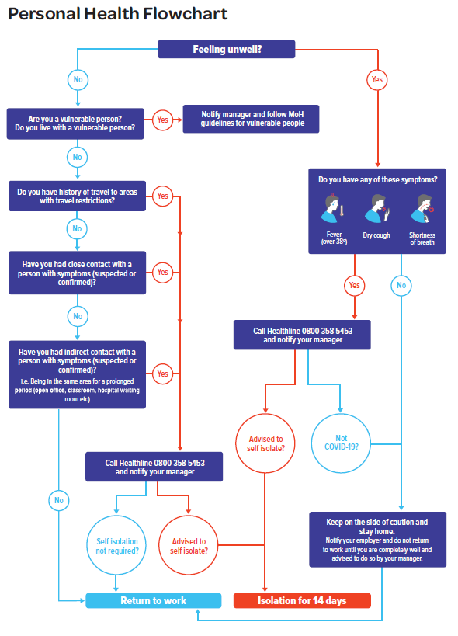

- 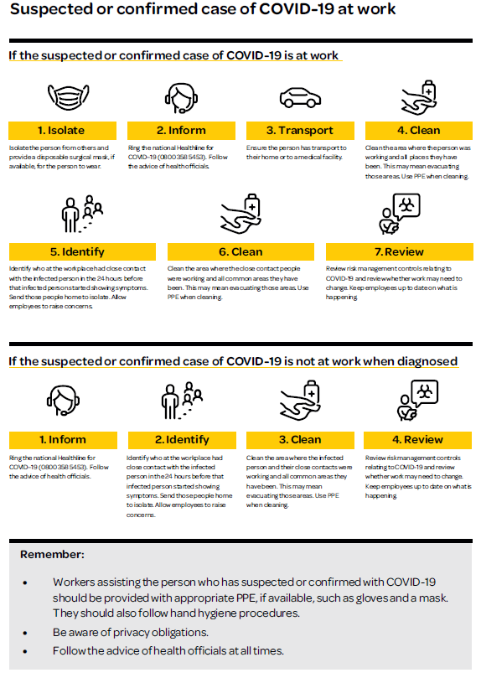

Travel to and from work
Transporting staff while remaining compliant with COVID-19 protocols is challenging. The following guidelines cover situations that are common in forestry where sites are remote, many staff travel a considerable distance to work and may rely on carpooling or crew vans.
Guidelines
  - General precautions that apply in all transport situations:
  - Workers MUST NOT travel if they have any symptoms of COVID-19 or have been in close contact with anyone with COVID-19
  - Always share the vehicle with the same group of people, including the driver
  - Employers should ensure that workers who travel together also work closely together (i.e. establish a work bubble)
  - Employers should provide a letter stating that the group has been designated as a “transport” bubble. The letter should name the people who may travel together, the vehicle they are travelling in, where people are travelling from and to. The letter should be provided to the accommodation provider (where applicable)
  - Do not use the vehicle for any other purpose such as transporting family when you are not at work
  - All workers should wash or sanitise their hands immediately before entering the vehicle and on leaving the vehicle
  - Workers should always sit in the same seat
  - Driver to clean and sanitise all surfaces after each trip and wash or sanitise hands.

All employers should:
  - Implement an approval process for all staff wishing to share transport
  - Maintain a register of all approvals
  - Provide the driver with a letter of approval
  - Provide a copy of the letter of approval to the accommodation provider (where applicable)
  - Position staff who share transport to work in proximity to each other and to share meal break times / locations etc. (i.e. create a work bubble).

Transport of staff within an accommodation bubble
  - No separation requirements exist when all of the people in the vehicle are from the same accommodation bubble, but general precautions listed above apply.

Transport of staff from different accommodation bubbles
  - It is understood that many people do not have access to individual transportation and therefore shared transportation is necessary. When this is necessary, the following precautions apply:
Car-pooling
- Do not use the vehicle for any other purpose – e.g., transporting your family when you are not at work
- Physical distancing between the driver and passengers is important, even in smaller vehicles
- Sit as far as possible from the driver. If you are the sole passenger, sit in the rear left-hand side passenger seat, diagonally opposite the driver
- The maximum number of passengers in a car is 3
- Apart from the driver, you must only travel in the same vehicle as people from the same isolation group (household unit or workplace bubble).

Larger vehicle e.g. vans.
- The driver must ask each passenger if they have any symptoms of COVID-19 before they enter the vehicle. Passengers with obvious symptoms must not enter the vehicle
- The driver must obtain and carry a letter from the employer stating the number of passengers that can be carried and in what formation
- Every passenger must wash or sanitise their hands immediately before entering and immediately after leaving the vehicle
- The driver is to wait outside the vehicle while loading and unloading
- Passengers to maintain maximum practical distance while loading and unloading
- Start filling the vehicle from the rear (seats furthest from the door)
- Passengers should always occupy the same seat
- Maximise spacing between passengers where possible for example: Only use the window seat in each row
- Use alternate rows
- Driver to clean and sanitise all surfaces after each trip and wash or sanitise hands.

- 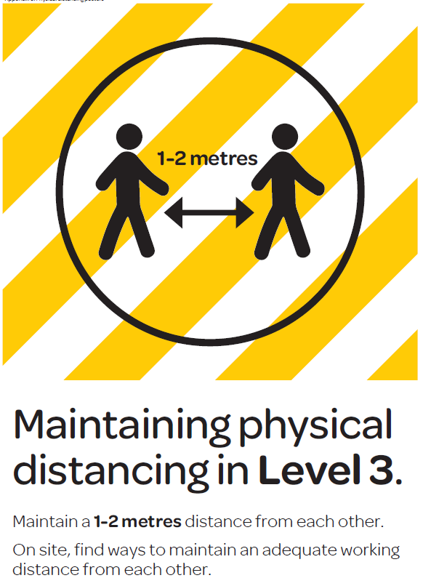

Sign off
Please sign below to indicate that you have read and understood the above.
Date | Name | Signature

